Project Akita — Phase I Prototype and User Manual
Team Luminous | CptS 484: Software Requirements | Fall 2026

1. Prototype overview
The Akita Phase I prototype is a low-fidelity mock-up demonstrating how a blind or visually impaired user could navigate an indoor building using voice commands, accessible buttons, spoken directions, and vibration cues.
The prototype focuses on the four scenarios from the Phase I presentation:
- Stevie finds the correct turn to reach his classroom.
- Maya receives a warning about a known hallway obstacle.
- Jordan receives emergency assistance after a possible fall.
- Emily finds an elevator and reaches the correct floor.
The prototype is intended to demonstrate the proposed user experience, not a fully functioning navigation system. For Phase I, the user's starting location is assumed or entered manually. Automatic indoor positioning, live obstacle detection, and actual emergency calls are not assumed to work in the mock-up.

Design principles
- Voice first: Users can operate the app without looking at the screen.
- Simple interface: Large, high-contrast buttons supplement voice commands and screen readers.
- Clear instructions: Directions use short phrases, step counts, and explicit turn or stop cues.
- Safety first: Warnings and emergency prompts take priority over ordinary navigation instructions.
- Assistive, not replacement: Akita complements a white cane or guide dog.

2. Prototype interface mock-ups
The Akita prototype is designed around a voice-first interface. Users interact with the application through spoken commands, audio instructions, and vibration feedback. Physical buttons and screen-reader-compatible controls provide alternatives when voice input is unavailable. The following mock-ups illustrate the intended interactions and are conceptual representations rather than screenshots of a working application.
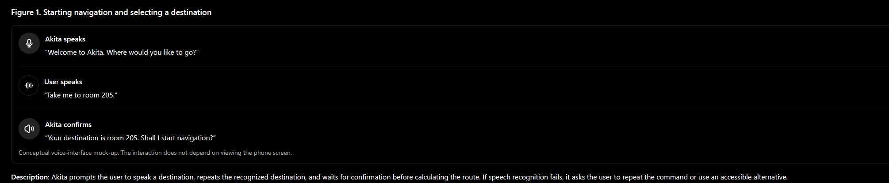
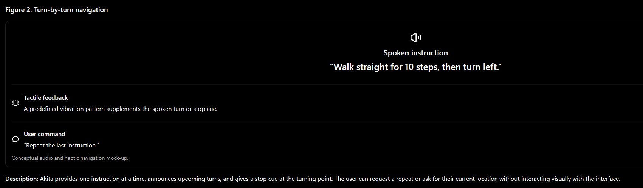
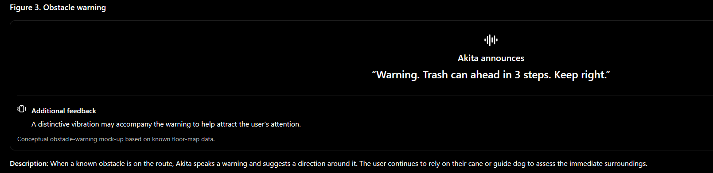
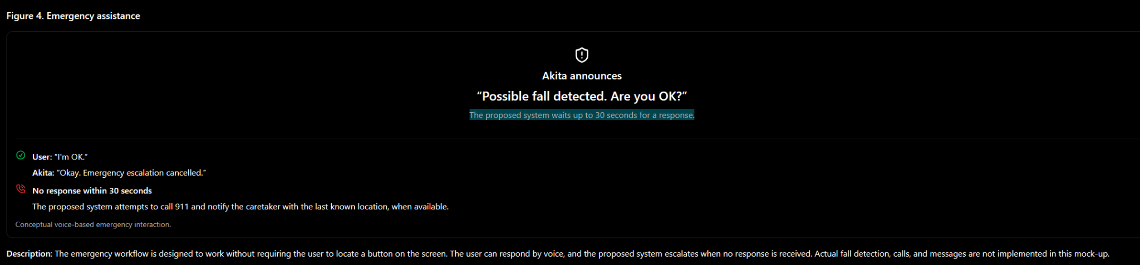

3. Basic user manual

Scenario 1: Stevie misses his turn
- Open Akita and listen to the spoken prompt.
- Say, “Take me to room 205.”
- Listen to the destination confirmation and say, “Yes.”
- Follow the spoken step counts and turn instructions.
- When Akita says, “Stop. Turn left now,” stop and make the turn carefully.
- Say, “Repeat,” whenever you need to hear the last instruction again.
Expected result: Stevie receives spoken guidance instead of having to estimate where to turn.

Scenario 2: Maya avoids a hallway obstacle
- Open Akita and provide the starting location if prompted.
- Say, “Take me to the library.”
- Confirm the destination and begin following the spoken route.
- Listen for warnings about known obstacles.
- When Akita says, “Trash can ahead in 3 steps. Keep right,” slow down and assess the path with your cane or guide dog.
- Follow the next spoken instruction when it is safe to continue.
Expected result: Maya receives an advance warning about the mapped trash can.

Scenario 3: Jordan needs emergency assistance
- Before navigation, configure the caretaker's contact details and emergency settings with assistance if necessary.
- Begin navigation normally.
- If a possible fall is detected, listen for Akita's prompt: “Are you OK?”
- If you are okay, say, “I'm OK,” within 30 seconds.
- If you need help and can respond, use the implemented emergency command or control, once that feature is supported.
- If you cannot respond, the proposed system attempts emergency escalation after 30 seconds, contacting emergency services and notifying the caretaker.
Expected result: The proposed system can initiate emergency assistance without requiring the user to navigate a visual menu.
Limitation: This behavior is a design proposal. The Phase I prototype does not perform actual fall detection or emergency communication.

Scenario 4: Emily wants to find the elevator
- Open Akita and say, “Take me to room 301.”
- Confirm the destination when Akita reads it back.
- Follow the spoken instructions to reach the elevator.
- Listen for the instruction to travel to the third floor.
- When Akita announces, “Third floor reached. Exit and turn left,” follow the directions carefully.
- Continue following spoken guidance until Akita announces arrival at room 301.
Expected result: Emily receives spoken guidance through the floor change without needing to read elevator signs.

4. General voice commands
Voice command | Intended response
“Take me to room 205.” | Set the destination and request confirmation
“Repeat.” | Repeat the last instruction
“Where am I?” | Announce the current or last known location
“I'm OK.” | Respond to the emergency prompt
“Stop navigation.” | Stop route guidance
“Change volume.” | Open or adjust the spoken volume setting, subject to implementation
These commands describe intended behavior; their availability depends on the features implemented in the final application.

5. Accessibility and safety requirements
- Voice must be the primary interaction method.
- Spoken instructions must communicate all essential navigation and emergency information.
- Vibration should supplement spoken instructions, not replace them.
- Screen-reader-compatible controls should be available as a backup.
- The user must be able to repeat instructions and stop navigation.
- Akita must supplement, not replace, a white cane or guide dog.
- Emergency and obstacle-detection features must be tested before real-world safety claims are made.
This revised prototype emphasizes the actual user experience for blind people: the interface is primarily what Akita says, how the user responds, and how the phone communicates through vibration—not what appears on its screen.

6. Conclusion
The Akita Phase I prototype presents a consistent, voice-first interface for indoor navigation and emergency assistance. Across the four scenarios, the user can select a destination, receive step-by-step guidance, hear known-obstacle warnings, navigate between floors, and interact with a proposed emergency workflow.
The prototype supports the team's requirements-engineering objectives by showing how the proposed requirements could translate into practical user interactions. Future implementation should validate the accessibility, reliability, location accuracy, obstacle-warning timing, and emergency-response behavior before the system is relied upon in real-world navigation.

